Social media

Current situation
At present JIVE operates three social media channels Facebook, Twitter and YouTube, plus the Daily Image page on the ASTRON website. Facebook and Twitter were ‘cleaned’ and information streamlined across the channels in May 2018.

Facebook: The JIVE Facebook page was established on 25th March 2011 and has been the most consistently active form of social media that JIVE has engaged with over the previous years. It generally caters for the ‘JIVE community’, for example current employees, alumni and colleagues. A light-hearted and friendly tone is adopted, and a mix of accomplishments, news and activities are shared through this channel. It has a relatively small presence compared to host organisation ASTRON. Posts are currently scheduled for evenings (see ‘How to publish a Facebook post’ on the JIVE wiki under JIVE PR)

Twitter: The Twitter account for JIVE was established on 8th April 2011. It was inactive for 3 years and 3 months (from 18th December 2013) before being reactivated on March 14th 2017. The JIVE followers are largely compiled of academics and organisations with a strong link to Space and Astronomy. Hootsuite is currently used to schedule tweets (see ‘How to Tweet’ on the JIVE wiki under JIVE PR).

YouTube: There has been no activity on the JIVE YouTube channel since 2012.

Daily Image: The continuation of the Daily Image is currently under review with the ASTRON communications team. It will be reworked alongside the new ASTRON website.

Quarterly Review (01 Apr – 01 August 2018)
Each quarter (01 Jan, 01 Apr, 01 Jul, 01 Oct) a review of the channels is given with a plan for the subsequent quarter.

Twitter – 317 followers
Followers increased by 22% (57). Tweets earned, on average (approximately), 21,500 impressions each month – giving an engagement rate of 1.1%. JIVE was mentioned 233 times (although this should not be considered a reliable indicator of engagement) and the JIVE twitter profile was visited a total of 1,729 times.

Top performing, by far (14,646 impressions), was: “*New* images from a super-telescope bring astronomers a step closer to understanding dark matter 📡📡

Astronomers using the European VLBI Network of telescopes have produced one of the sharpest astronomical images ever. Read more at: jive.eu/new-images-sup… pic.twitter.com/7XzaFF9S4W”

The Twitter audience has a large male bias: 80% male 20% female. The top five countries represented by the audience (percentage) are:
- United Kingdom 15
- Netherlands 14
- USA 12
- Spain 07
- Germany 07

Audience interest by percentage:
- Weather 97
- Space and Astronomy 94
- Science news 94
- Tech news 92
- National parks 86

Facebook – 430 followers
Followers increased by 8% (33). On average posts reached 72 people, with the top performing post reaching 1,086 people – this was a video post on 14 June: “Joint Institute for VLBI ERIC: Surprise discovery provides new insights into stellar deaths”

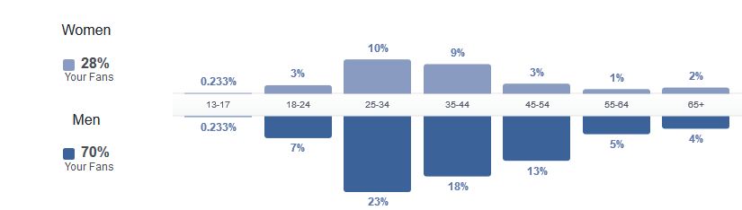
Figure 1 Audience demographics Facebook
The top five countries represented by the audience (total number) are:
- The Netherlands 77
- USA 51
- India 39
- Germany 27
- Australia 20

YouTube – 11 subscribers
There has been no activity on the JIVE YouTube channel since 2012.

Daily Image
7 daily images were submitted during this period. A record of these can be found on the JIVE wiki under JIVE PR (password protected).

Long term social media goals (12 months to October 1st 2019)
- Increase image (all posts on Facebook, 60% on Twitter) and video content posts (1 per month on Facebook and Twitter);
- Share content on what JIVE does, not just achievements but day to day working and ‘institutional behind the scenes’ insights to build trust and understanding;
- Increase online audience to reach 1000 followers on Twitter, and 750 followers on Facebook.
- Increase engagement with posts on Twitter (engagement rate >5%) and Facebook (>100 impressions on average)

Short term social media goals (3 months Oct-Dec)
- Schedule regular posts on Twitter (3 times per day) and Facebook (3 times per week);
- Follow all institutions, associated projects and individuals collaborating or partnering with JIVE, link to these wherever possible to build online network;
- Share all publications and event attendance to show support for community;
- Invite Facebook users who engage with content but do not follow the page to follow us;
- Increase online audience by 50% on Twitter to 475 followers, and by 20% on Facebook to 516 followers.
- Increase engagement with posts on Twitter (engagement rate >3%) and Facebook (>80 impressions on average)

Information taken from Twitter Analytics: https://analytics.twitter.com/user/jivevlbi/home
Engagement rate refers to the number of engagements (clicks, retweets, likes, replies, follows) divided by the total number of impressions
Information taken from Facebook Insights: https://www.facebook.com/JIVEVLBI/insights/?referrer=page_insights_tab_button

