
Express Production Real-time e-VLBI Service
EXPReS is funded by the European Commission (DG-INFSO), Sixth Framework Programme, Contract #026642

Monthly Report- Jan 2009
Date: | 2009 Feb 01
Filename: | 2009-jan-rev03.odt
Author: | T. Charles Yun, Project Manager, JIVE
Co-Authors: | EXPReS Management Team
Summary: | Monthly report

Document Log
Version | Date | Summary of Changes | Author(s)
1.0 | 2009 Feb | final
0.9 | 2009 Feb 02 | Draft | tcyun
0.1 | 2009 Jan 29 | Initial Draft | T. Charles Yun

Project Information
Project Acronym | EXPReS
Project Full Title | Express Production Real-Time e-VLBI Service
Proposal/Contract number | DG-INFSO #026642

Table of Contents
1. Introduction
2. Network Activity Updates
* NA1- Management
* NA2- EVN-NREN
* NA3- e-VLBI Science Forum
* NA4- Public Outreach, Dissemination and Communications
3. Specific Service Activity Updates
* SA1- Production e-VLBI Service
* SA2- Telescope Network Connections
4. Joint Research Activity Updates
* JRA1- FABRIC

Section 1- Introduction
January has been busy for most activities, but not directly in response to deliverables. Instead, the rest of the world has begun to understand the accomplishments of the project and we have been demonstrating our progress through a variety of on site displays and interactions with press and the general public. Closer to the project, the Board Meeting
Section 2.1 – NA1 Management
The project office has been busy with a variety of internal activities relating to changes caused by the 6 month project extension. A variety of partners have asked about the ability to conduct audits of 18 month periods, costs related to the audits and related issues.
In November, the Project Manager presented slides at ICT 2008 in Lyon, France covering activities in EXPReS. A summary of the talks given at that session was just published. Both of the presentations have been made available on the project wiki in the "Past Meetings and Conferences of Interest" section accessible from the main page.
The primary management activity for the month has been the Board Meeting. On 21 Jan, the Board met in Madrid, Spain hosted by our partners CNIG-IGN. On the agenda were a variety of important items, including discussion of CNIG-IGN's legal status as a partner and budget discussions. The meeting concluded with a few very specific action items that should not require much time to complete. Minutes are currently in preparation and will be posted on the wiki as soon as they are available.
Section 2.2 – NA2 EVN-NREN
In Lyon, France, the John Chevers and the Project Manager had an opportunity to discuss that status of the activity. In general, it is believed that the overall operational status of e-VLBI means that the cummunications between the EVN and the NRENs are much improved compared to the beginning of the project. There are still some items to discuss about global network routes and the subsequent meeting will touch on this issue. Which leads directly to the topic that there are plans for the final EVN-NREN meeting to be held in conjunction with the end-of-project eVSAG meeting in Madrid. Further details on this once the meeting planning has progressed.

Section 2.3 – NA3 eVSAG
As with the past few months, the eVSAG is preparing for the end of project workshop. The (internal) invited speaker list is nearing completion and the open call should come quickly after that. The website has begun to reveal more information compared to the basic announcement that was visible at the end of the previous year. The meeting is also far enough along in planning that it is breaking out of the pure eVSAG circle- outreach has already produced a poster, the Project Office is now involved in local planning, etc.
Section 2.4 – Public Outreach
The biggest activity for the month was the UNESCO International Year of Astronomy Kickoff event held in Paris, France. EXPReS has worked closely with the organizers to provide a strong EXPReS (e-VLBI, radio astronomy) presence at the site. Additional information on IYA is available at <www.astronomy2009.org>. The IYA generated a great deal of exposure for EXPReS. A list of press releases and news mentions is available via the project website at <http://www.expres-eu.org/news.html>. Of particular noteare the mentions on the INFSO newsroom page and the New Scientist column.
Activity in support of the end of project science and technology workshop is also underway. The physical copy of the poster was mailed to institutes around the world encouraging participation. Preparation for the proceedings is also underway with PoS.
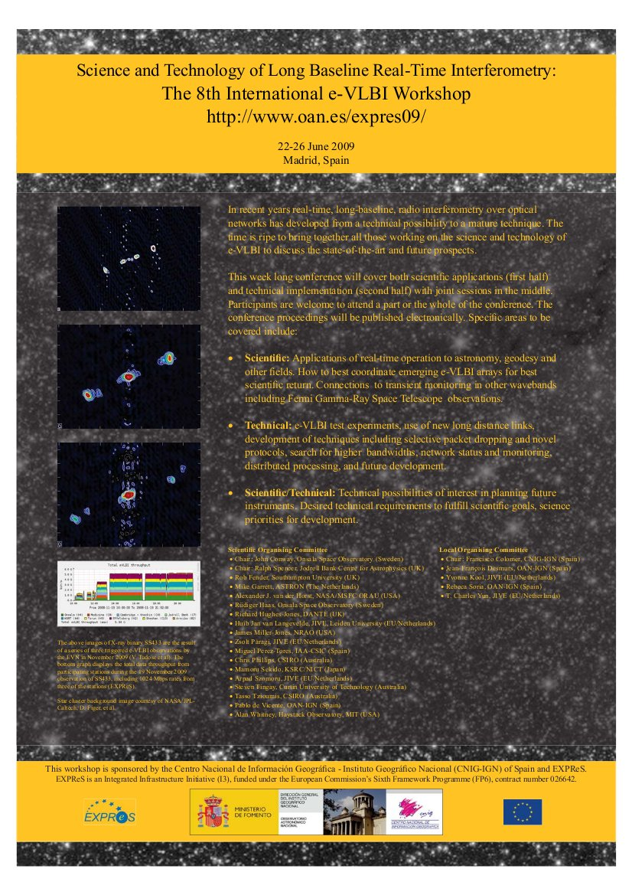
Poster for the end of project science and technology meeting

Section 3.1 – Production e-VLBI Correlation
The 2009 e-VLBI call for proposals was distributed and lists the following dates for production e-VLBI:
2009 Feb 10 - Feb 11
2009 Mar 24 - Mar 25
2009 Apr 21 - Apr 22
2009 May 19 - May 20

As mentioned, the UNESCO IYA kickoff included an on-site demonstration of e-VLBI. For the demonstration, 17 radio telescopes around the world conducted a successful e-VLBI observation of nearly 33-hours, tracking three quasars as they rose and set with the rotation of the Earth. Three hand-crafted images of the target source J0204+1514 are now available.
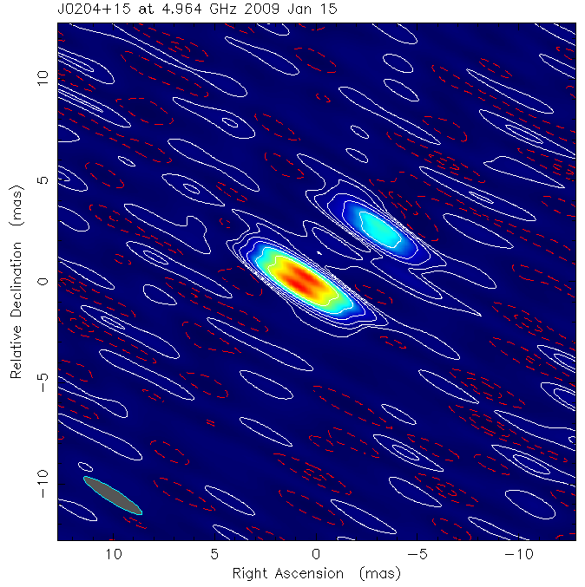 | 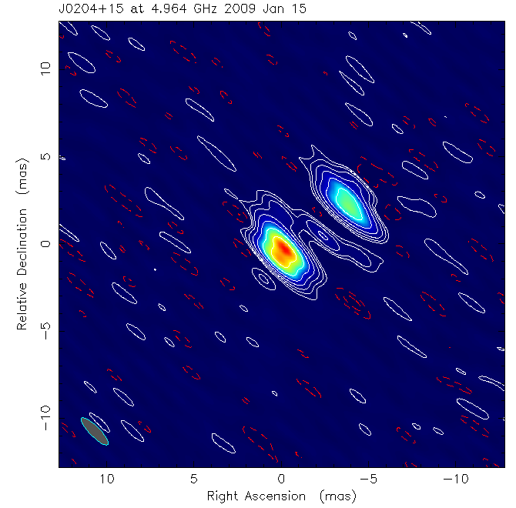 | 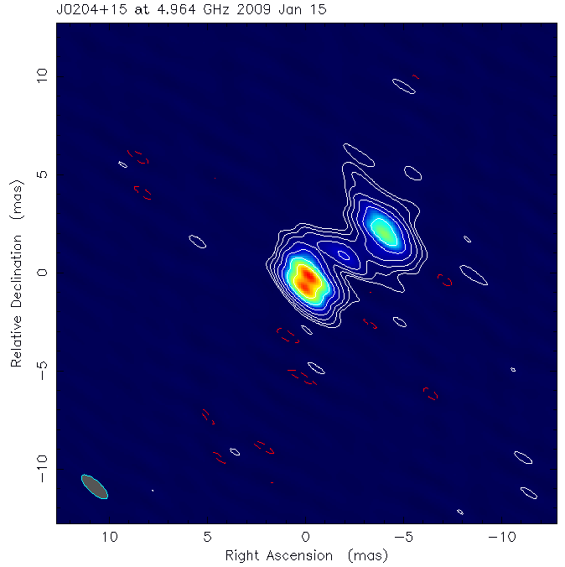
Three images from the observation during the UNESCO IYA event. Note that over time (left to right), the image resolves, showing more details of the source and less noise in the background.

Participation in the kickoff event was rewarding for a variety of reasons. First, the EXPReS demonstration was the only display showing astronomy in progress. The images that were shown were observations happening in real time. The fact that this was possible highlighted the stability and confidence in the system that is being used, along with some interesting new pipeline elements being used for the first time.
Section 3.2 – Telescope Network Connections
At the Board Meeting, Paco Colomer provide an update on the status of the activity. The good (great) news is that many of the "wished for items" on his list at the end of last year are completed (connectivity for Effelsberg, Yebes; 10 Gbps tests for Metsahovi, Onsala). As we are approaching the end of the project, those partners who have not completed their connection will need to be seen as having made progress, but not completed their activities. We will spend the next few weeks addressing these items individually.
Section 4.1 – FABRIC
The FABRIC group has spent a bit of time updating the deliverables table after a bit of neglect over the past few months. A variety of deliverables have been marked as complete and the associated documentation has been uploaded onto the wiki. Of particular note are some of the software based deliverables. For these items, tarballs (tar.gz) have been uploaded. All of the code now compiles (with varying degrees of ease) and functions (with much use of '--help'). A great deal of the code uploaded will only ever be used by correlator operators. This means that muc of the documentation is included in the code or is integrated into the operational procedures at JIVE. The biggest accomplishments the availability of stable software correlator and workflow manager code bases. This now means that the two parts can undergo integration testing and validation.

