
Express Production Real-time e-VLBI Service
EXPReS is funded by the European Commission (DG-INFSO), Sixth Framework Programme, Contract #026642

Monthly Report- July 2008
Date: | 2008 Jun 5
Filename: | 2008-apr-may-jun-rev05.doc
Author: | T. Charles Yun, Project Manager, JIVE
Co-Authors: | EXPReS Management Team
Summary: | Monthly report

Document Log
Version | Date | Summary of Changes | Author(s)
1.0 | 2008 Aug 12 | final
0.9 | 2008 Aug 11 | Draft | tcyun
0.1 | 2008 Aug 5 | Initial Draft | T. Charles Yun

Project Information
Project Acronym | EXPReS
Project Full Title | Express Production Real-Time e-VLBI Service
Proposal/Contract number | DG-INFSO #026642

Table of Contents
1. Introduction
2. e-VLBI Workshop
3. Collected Updates

Section 1- Introduction
The summer season is generally the slowest part of the year and this summer is no exception. Many of the project members indicated that they would be away for the holidays. As this is the case, this month's report will be condensed into one section covering the most obvious activity since the last report (the e-VLBI workshop) and then a section covering remaining items.
Please note that we are considering moving to OpenOffice <http://www.openoffice.org/> as the software that generates the PDF documents that we share with the Commission. This document was generated and completely via OpenOffice. Please let us know if there are any problems with the PDFs you receive.
Section 2- e-VLBI Workshop, Shanghai, China
The 7th International e-VLBI Workshop was hosted by EXPReS partner Shanghai Astronomical Observatory (ShAO) in Shanghai, China. The workshop agenda, presentation and photographs are available from their website <http://www.shao.ac.cn/eVLBI2008/>. EXPReS partners made a large contribution to the workshop providing presentations in every workshop segment as well as providing posters. The EXPReS display was also presented during the workshop.
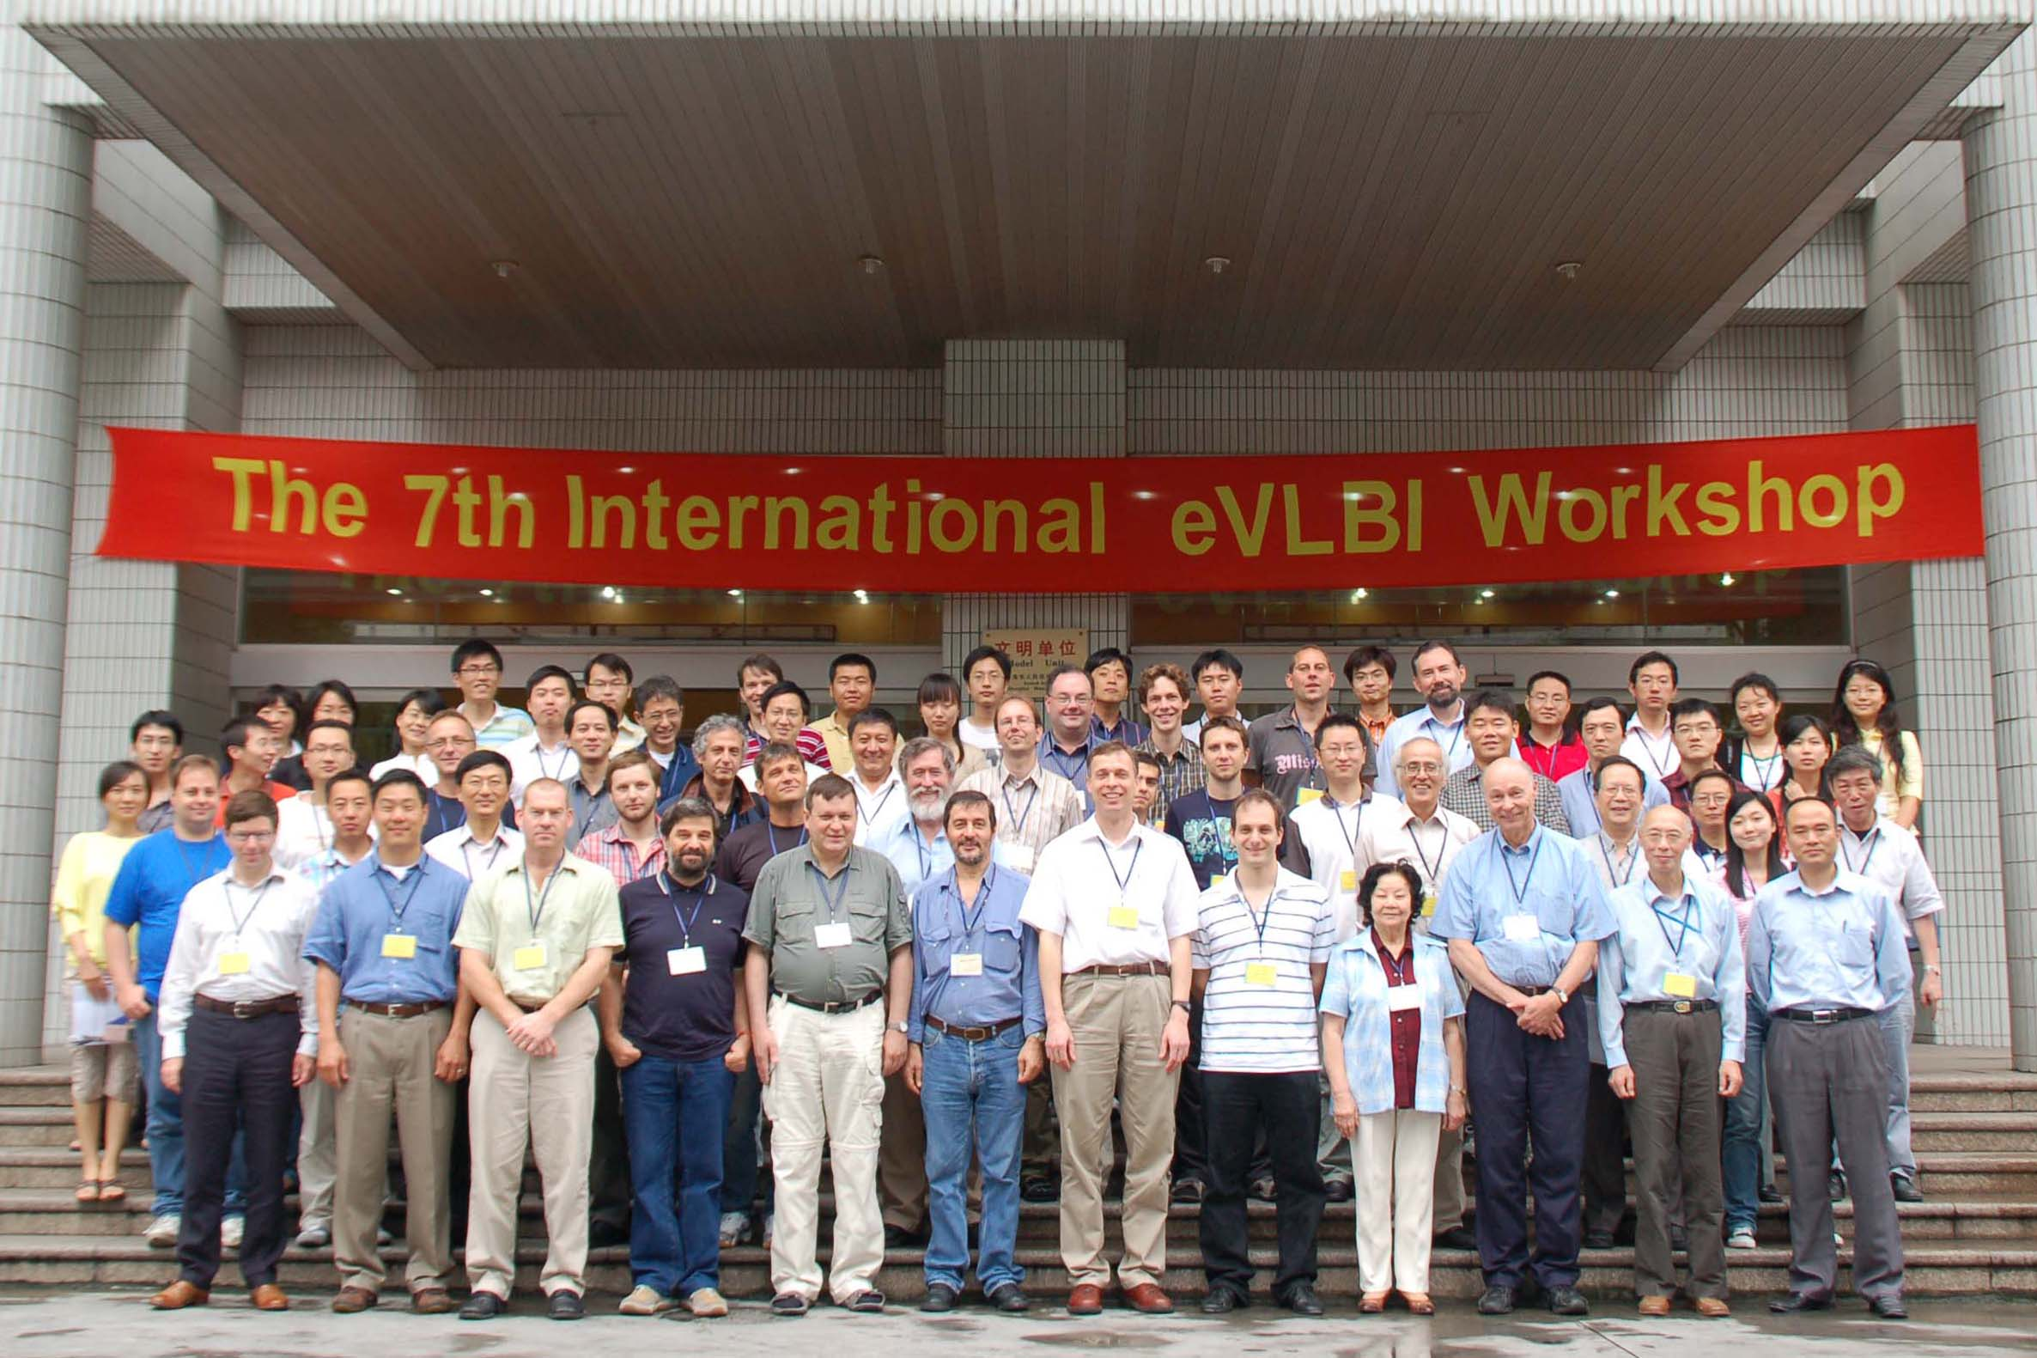
Group photograph from the e-VLBI workshop, photo credit ShAO, <http://www.shao.ac.cn/eVLBI2008/>

After the meeting, thank you notes from the host, formal summaries of discussions and a general announcement email were distributed both to workshop participants and inside of the VLBI community via email lists.
At the workshop, our Finish partners at Metsahovi demonstrated an eight Gbps per second data transfer over commodity Internet. It is important to note that the demonstration was made possible due to extensive cooperation with the region's NREN's, Funet, Sunet and Nordunet. This demonstration highlights the progress made in the community and the flexibility that is now possible to combine commodity networks, point to point connections and dedicated fiber paths.
Section 3- Collected Updates
Yebes- Start of 1 Gbps link construction
The project office received word that Yebes has begun work on connecting their telescope at 1 Gbps. The work is currently underway and expected to be completed in November of this year.
EXPReS Visit to KVN
After the e-VLBI Workshop, the EXPReS Project Manager was invited to give a general EXPReS update talk to members of the KVN in Seoul, Korea. The overview presentation was a change to introduce the activities of EXPReS and to begin conversations regarding future work. It was encouraging to see that institutes who are not currently participating in EXPReS are eager to join follow-on efforts as they see EXPReS to be leading the world-wide effort in e-VLBI.
Jive-5a Software release
As part of the efforts to make e-VLBI more robust, EXPReS partners have been working to stabilize the operational VLBI software. JIVE has released a software package called Jive-5a <http://www.jive.nl/~verkout/evlbi/jive5a-1.0.tar.gz > which is a subset of the MIT Haystack Mark 5 command set. The Jive5a software is optimized for e-VLBI.
Astronomer's Telegram
Astronomer's Telegram #1597 was published on 2 July 2008, reporting on the observation of X-ray source 2MASX J20183871+4041003 using the European VLBI Network in e-VLBI mode. See http://www.astronomerstelegram.org/?read=1597. An image created from this observation has also been submitted for the ASTRON/JIVE Image of the Day (http://www.astron.nl/dailyimage/).
Real-time transfer of 1024Mb/s between WSRT and JIVE
From the email announcement:
This afternoon we succeeded in transferring formatter data at a rate of 1024Mb/s from the WSRT to JIVE... As 1024Mb/s simply won't fit through a 1Gbps ethernet connection, we areusing the Linux 'ethernet bonding' driver to create a virtual network interface that consists of two 1Gb/s ethernet cards. Traffic sent to this virtual interface will be transmitted over both physical interfaces in a round-robin fashion so that even at 1024Mb/s, each physical
interface only transmits 512Mb/s of the traffic.
This is a fundamentally exciting improvement and makes possible better utilization of existing resources and provides improvements for the science.
Public Outreach Summary

Several articles and press releases from the four-continent e-VLBI session demonstrated at TERENA Networking Conference '08 were posted by numerous web sites in June, including CORDIS, RedOrbit.com, Universe Today, SpaceDaily and NewScientist.com. Links to articles are available via the EXPReS website.
Hayo Hase from TIGO (Santiago, Chile) emailed the project office to let us know that local newspapers had published articles highlighting the EXPReS work being done. Copies of the articles are available on the web via:
http://www.reuna.cl/documentos/redenaccion/REDenACCION_16_junio2008.pdf
http://www2.udec.cl/panorama/p624/p04.htm
Planning is underway for the ASTRON/JIVE Open Day on 19 October 2008. EXPReS will be represented by staff, posters, brochures and in-person description of the correlator and the advantages gained through real-time e-VLBI. Posters highlighting the roles of women in astronomy and engineering will also be on display.

.

