
Express Production Real-time e-VLBI Service
EXPReS is funded by the European Commission (DG-INFSO), Sixth Framework Programme, Contract #026642

Monthly Report- Aug 2008
Date: | 2008 Sep 13
Filename: | 2008-aug-rev05.odt
Author: | T. Charles Yun, Project Manager, JIVE
Co-Authors: | EXPReS Management Team
Summary: | Monthly report

Document Log
Version | Date | Summary of Changes | Author(s)
1.0 | 2008 Sep 12 | final | tcyun
0.9 | 2008 Sep 8 | Draft | tcyun
0.1 | 2008 Sep 4 | Initial Draft | T. Charles Yun

Project Information
Project Acronym | EXPReS
Project Full Title | Express Production Real-Time e-VLBI Service
Proposal/Contract number | DG-INFSO #026642

Table of Contents
1. Introduction
2. Network Activity Updates
3. Specific Service Activity Updates
4. Joint Research Activity Updates

Section 1- Introduction
The Project Manager was away for most of the month on holiday, so the updates are fairly short this month. Each of the activities have been collapsed into one section for this report. Interestingly, the activities for this month seem to fit will with this plan; the NAs are primarily planning across activities and the SAs are cooperating on moving newly installed fiber to tested and operationally ready fiber.
Section 2.1 – NA1-4 Networking
The 9th European VLBI Network Symposium will be held in Bologna from 23-26 September 2008. The meeting is the regular meeting of the EVN where a broad range of science topics are covered. Additional information is available via <http://www.ira.inaf.it/meetings/evn9/>.
The Project Office (via NA4) has begun planning for the Effelsberg Connectivity celebration. Still in the early stages, an event at the Effelsberg telescope is being planned to celebrate its connectivity via high-speed fiber optic cable (and thus its ability to participate in e-VLBI). The event will be planned along with members of MPIfR and additional details will be made available via the website.
The new EXPReS Board Chair has sent an email to the activity leaders reminding them about potential dates for the next Board Meeting. The discussion seems to be closing/agreeing on a date in late January 2009. The official date will be communicated to the Board via email and with supporting logistics once final details are available.
An interesting aside, members of EXPReS have been asked to participate in a hardware beta test by a network vendor. This is an encouraging sign as it means the corporate world has taken note of our activities. The only negative to this is that there may not be the manpower to participate properly. Further details will be provided if the program moves forward.
Section 3.1 – Production e-VLBI Correlation and Section 3.2 – Telescope Network Connections
One of the items that has been an ongoing point of difficulty internally is where SA2 ends and where SA1 starts. In many ways, SA2 has no deliverable other than a work order from an infrastructure organization indicating that a bundle of wires has been buried underground. Once the wires are in place, SA1's activities of testing the connection and optimizing the network come into play. This month's SA1 and SA2 activities are posted together as they show the interaction of the two groups,
We are happy to announce that in our tests on the 9th of September, we were able to demonstrate real-time fringes between Arecibo and several European EVN telescopes at a rate of 512Mb/s. This was made possible because of improvements in the network connectivity from Puerto Rico to the mainland USA via the PRISANET gigabit infrastructure jointly developed by the University of Puerto Rico, Centennial and the AO, and a dedicated network path all the way from Arecibo to JIVE. Please see the attached images of the networking throughput and fringes.

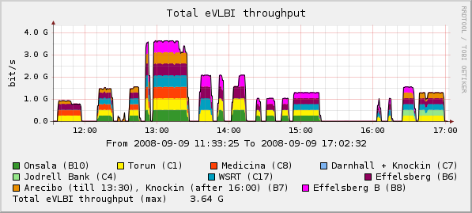
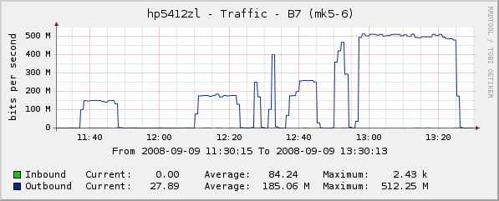
Network throughput showing real-time fringes between several telescopes at 512 Mbps

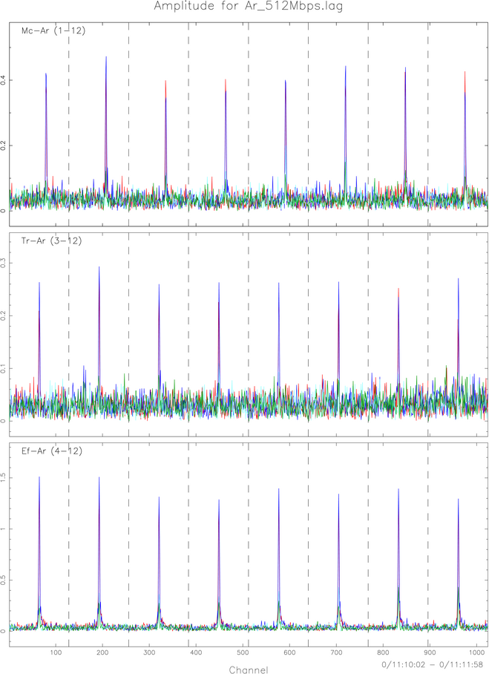
Fringes with Arecibo from three stations at 512 Mbps

Also this past month, the project performed a few networking tests on Tein2. All tests were done in UDP using iperf, with 1400 byte frames because Jumbo frames are not supported on the full path. All tests ran from SHAO to JIVE, testing the full path (CSTNET, CERNET, TEIN2, GEANT2, SURFNET). In order to send 512Mb/s of e-VLBI data with a 1500 byte MTU, we would need to achieve at least 528Mb/s.
In our tests, we found that up to 400Mb/s, the network performance was close to perfect, with only occasional packet loss. At speeds higher than 425Mb/s there is a steady packet loss of 1.3%, even at 525Mb/s. As we don't want to cause unnecessary congestion, we ran only short tests at these speeds once we noted the packet loss.
We would like to try to investigate where this packet loss occurs and if we can do anything about it. We will also be testing the lightpath via Canarie as a possible alternative.
CSTnet suggested they might try to get an iperf-server closer to Beijing to test with - if anyone else along this path could help us with similar testing, that would be much appreciated.
Also at the end of the month, JIVE was able to test dynamic switching between two sources during an e-VLBI run. A note was sent to the EVNtech mailing list announcing the achievement on 29 Aug. During the test, Torun and Westerbork switched from one source to another. Jodrell remained on the initial source. After fingers were found between Torun and Westerbork, the two dishes returned to view the original source with Jodrell. After the switch back, the three dishes were able to produce fringes between themselves. The ability to switch sources during a run is another important step in e-VLBI and dynamic, target of opportunity observations as the ability to redirect the dishes and provide fast feedback is essential. Additional details are available via the original email.
Section 4.1 – FABRIC
The FABRIC groups from JIVE and PSNC will hold a face to face meeting at PSNC. The meeting is scheduled for 1-2 September. (Note: The draft minutes from the meeting are being exchanged via email as this report is being prepared.) just after the meeting; the minutes should be available via the wiki by the end of the week.) The main purpose of the meeting is to re-synchronize the activities of the two groups. On the agenda are updates for the WFM, Broker and Networking interfaces. The morning of the second day will be spent as a more hands-on session so that the developers can address technical issues. Additional details are available on the wiki <http://www.jive.nl/dokuwiki/doku.php/expres:fabric-f2f-poznan>.

[photo]
Caption

